Name: Mrs. Rupali N Hosmani.

Course: Executive Post Graduate Certification in Cloud Computing

Contact No. 7720003531

**Assignment 3: Jenkins-Case Study**

**Task to be performed:**

1. Git Workflow has to be implemented

2. Code Build should automatically be triggered once commit is made to master branch or develop branch. If commit is made to master branch, build and publish website on port 82. If commit is made to develop branch, just build the product, do not publish.

3. Create a pipeline for the above tasks.

4. Create a container with Ubuntu and apache installed in it and use that container to build the code and the code should be on ‘/var/www/html’

Steps:

1. Launch 2 EC2 instances, Name as Master & slave

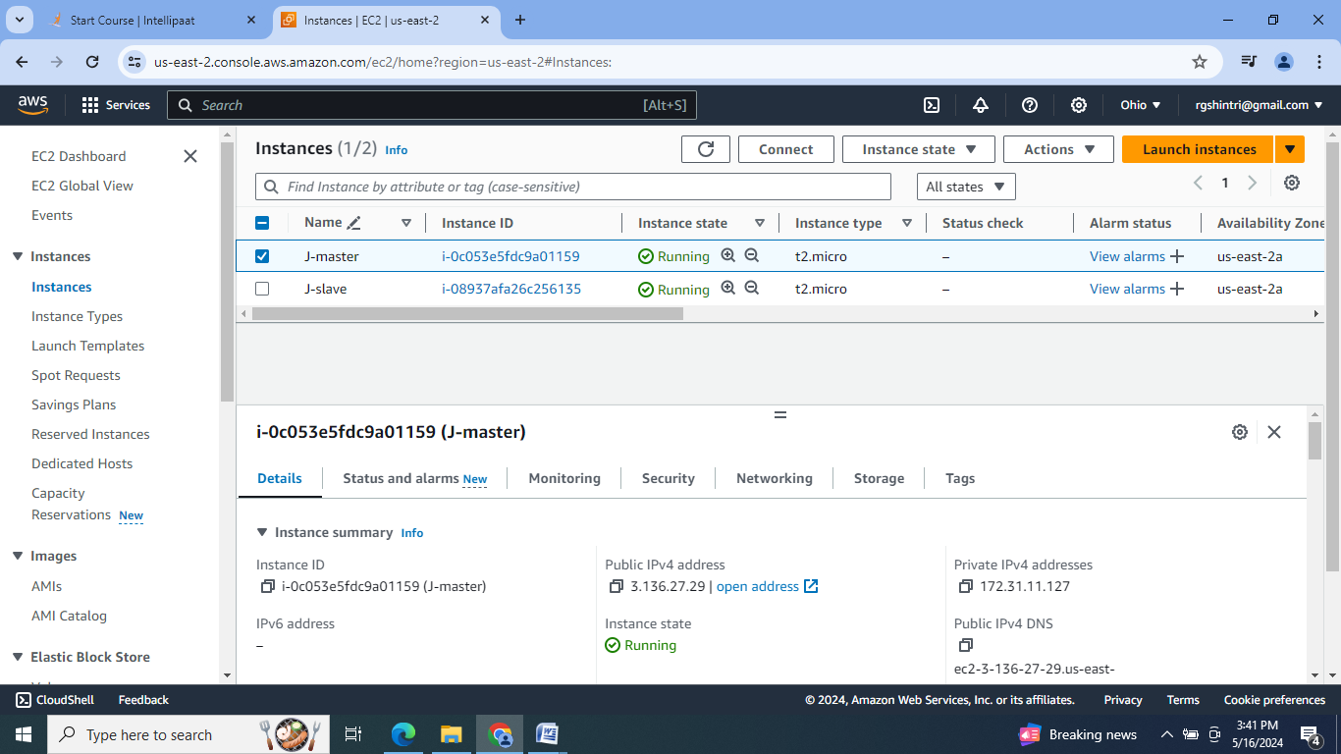

2. Install Jenkins, Java & Docker on master machine, & Java & Docker on slave machine.

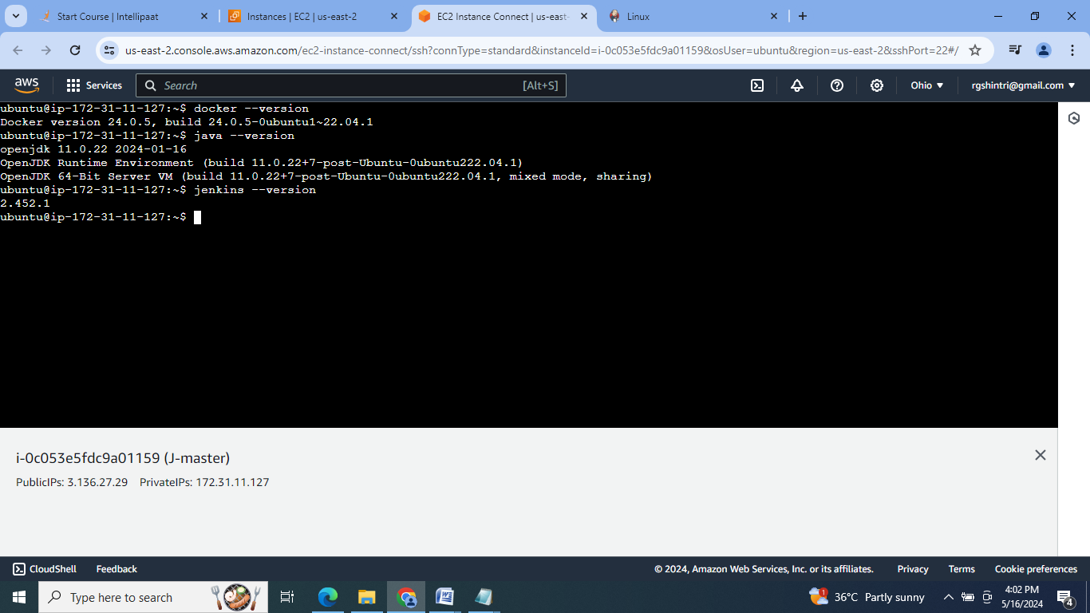

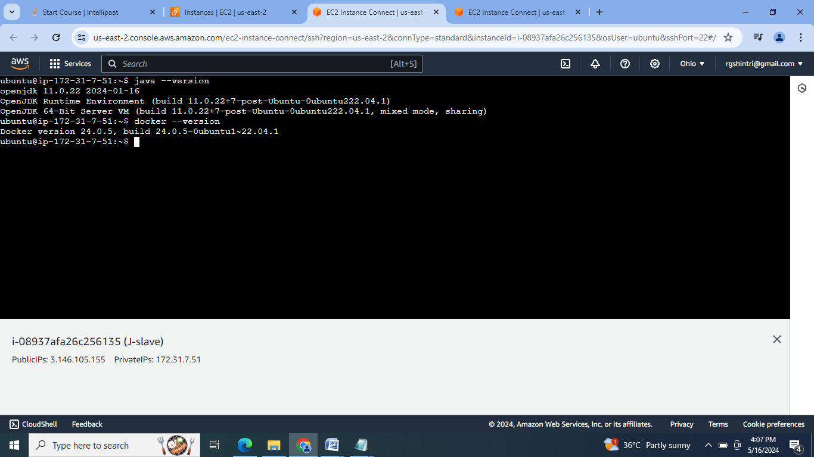

3. Create the keys for connection formation, copy this keys slaves authorized _keys:

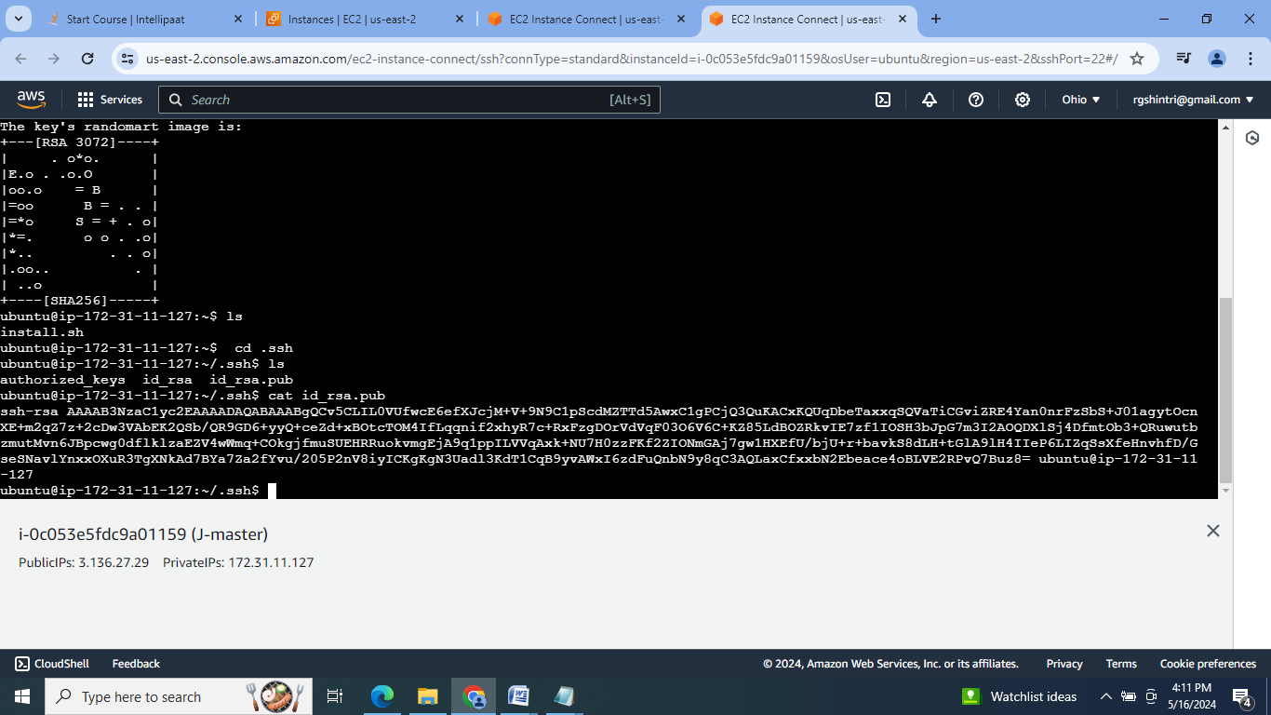

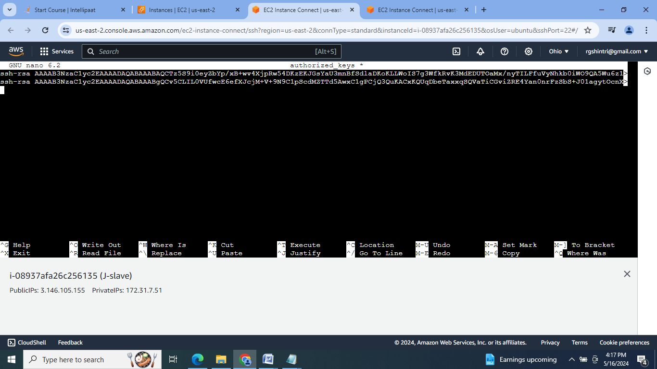

4. Check for master slave connection:

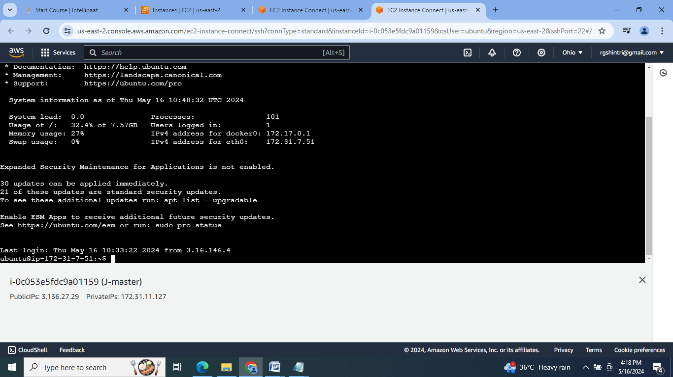

5. Set up Jenkins dashboard & login:

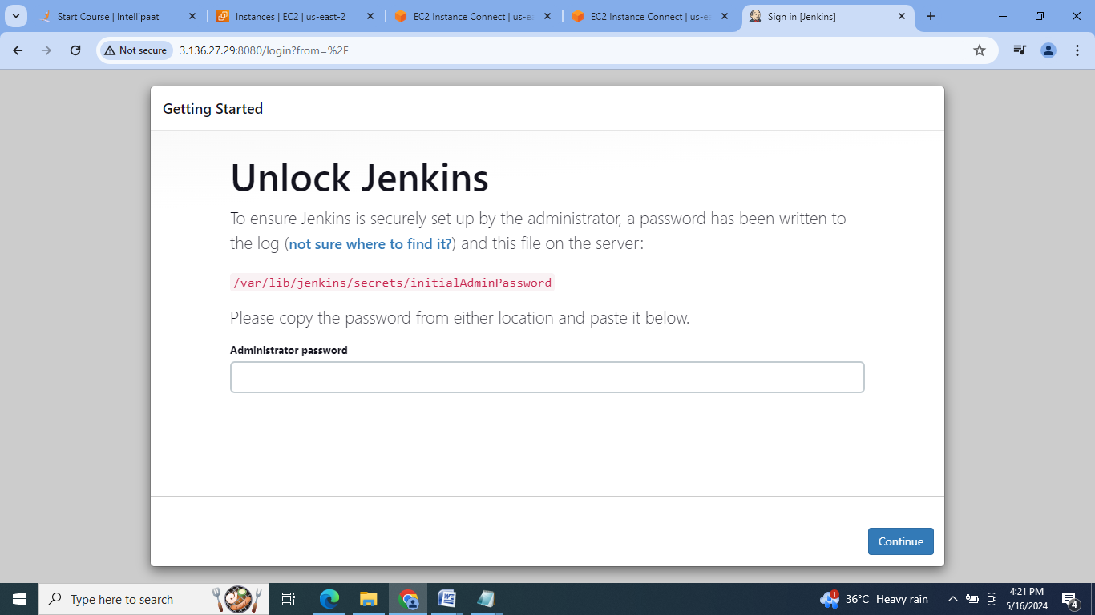

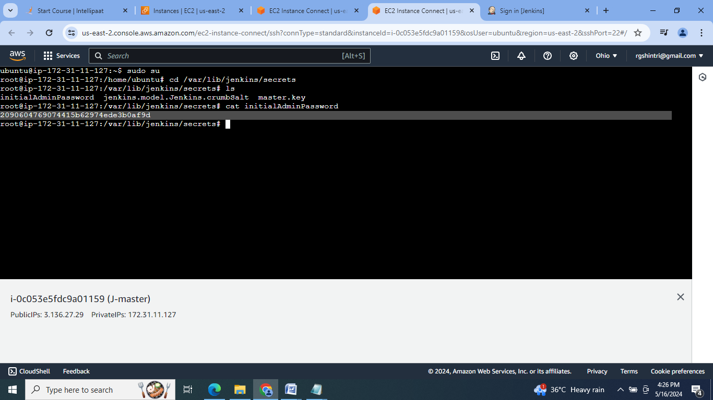

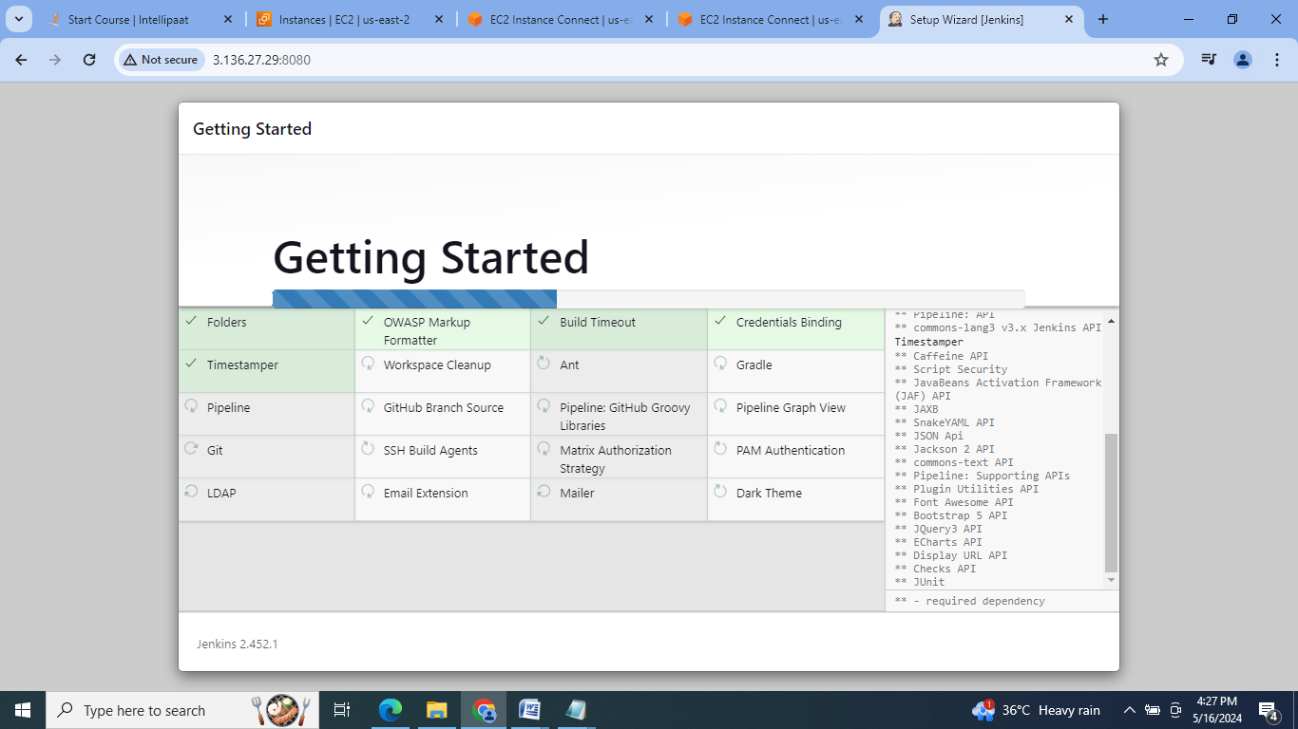

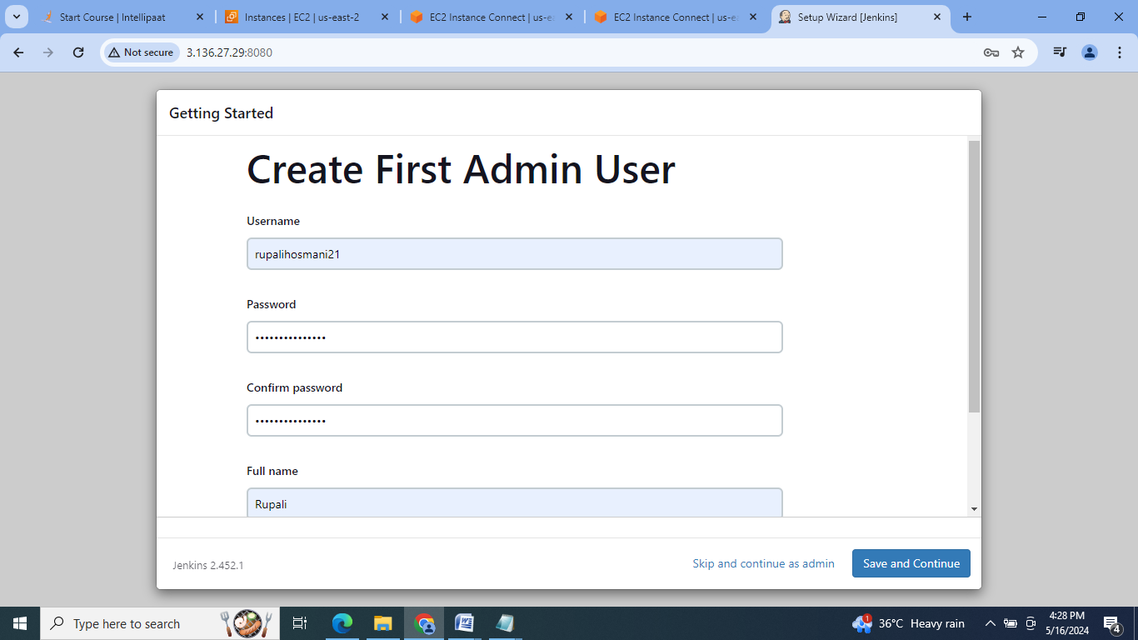

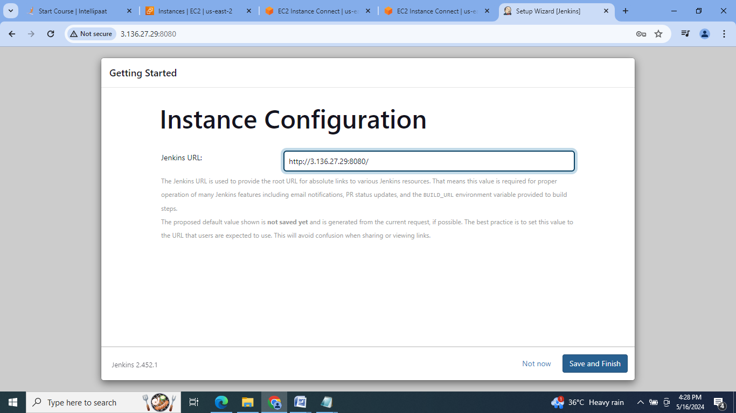

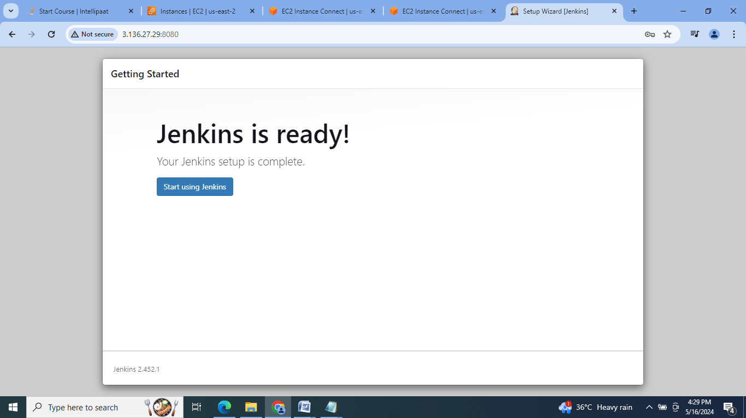

6. Configure the slave machine as node.

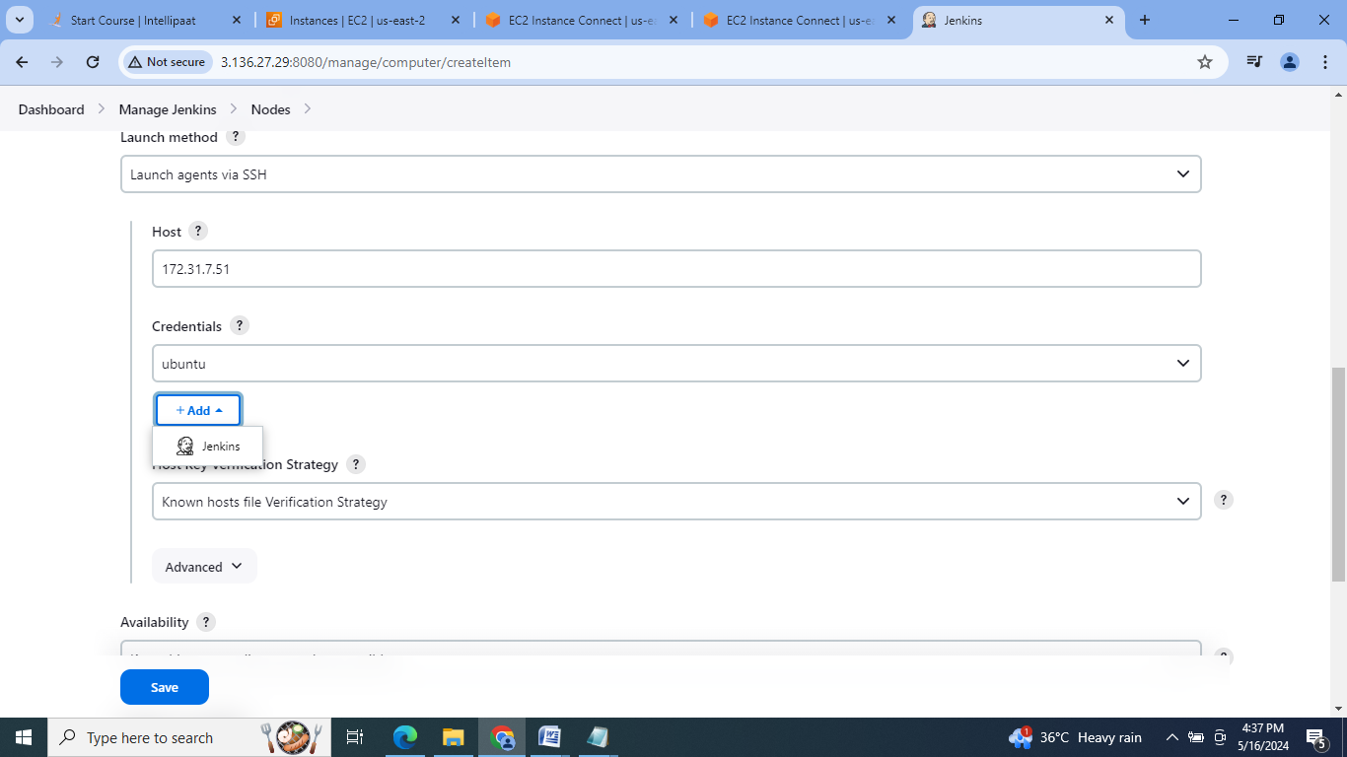

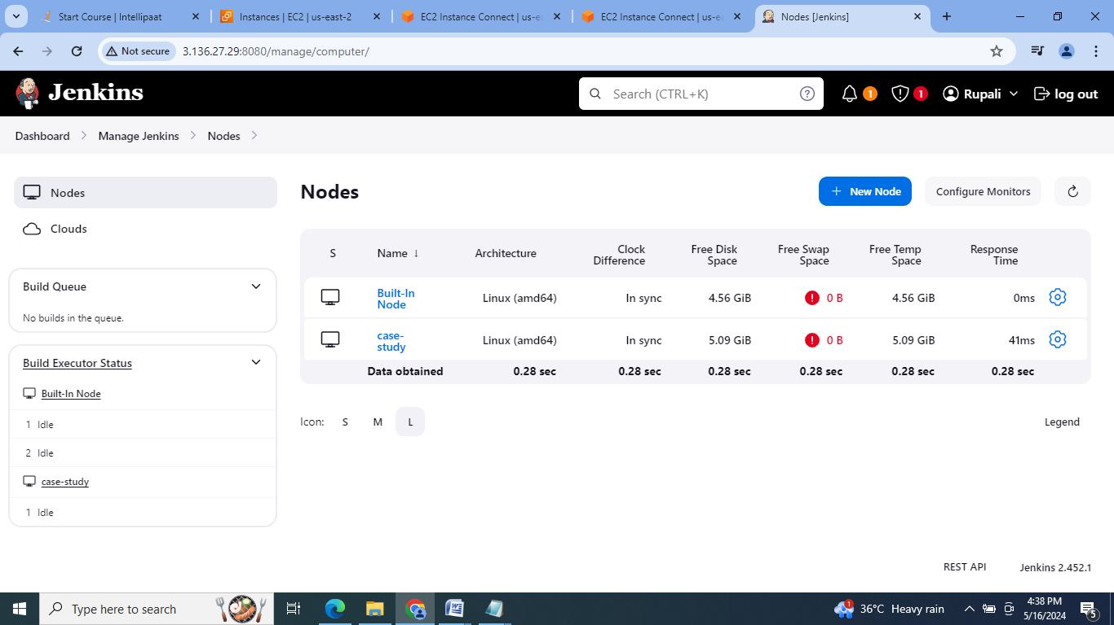

7. Fork the given gitHub repo in our github account:

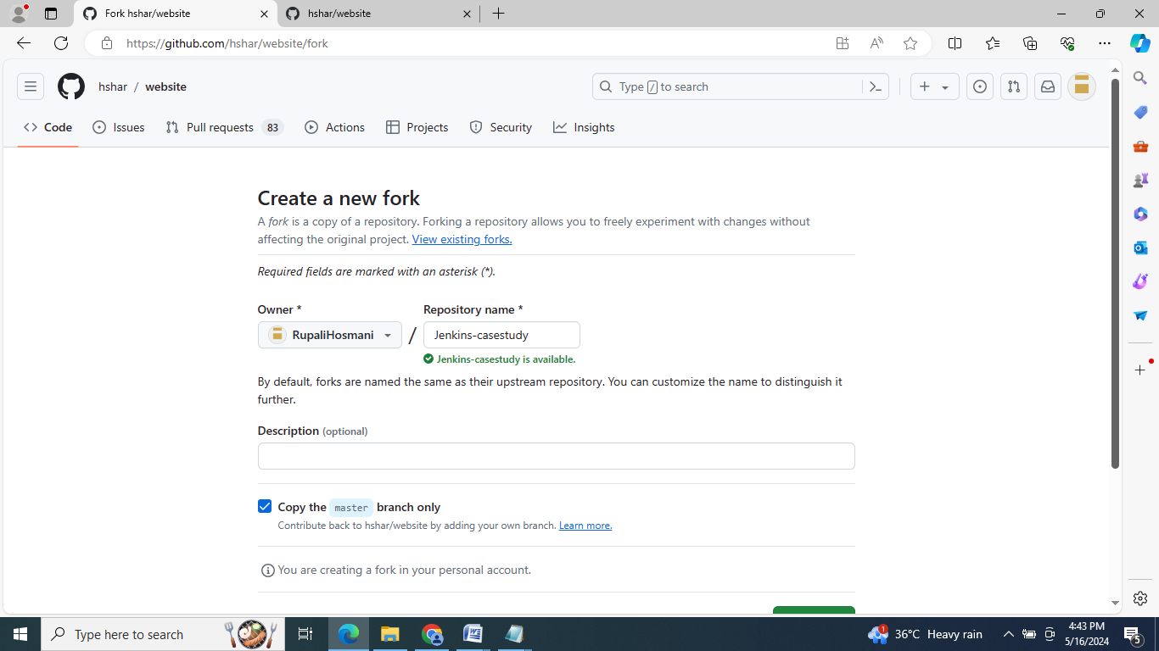

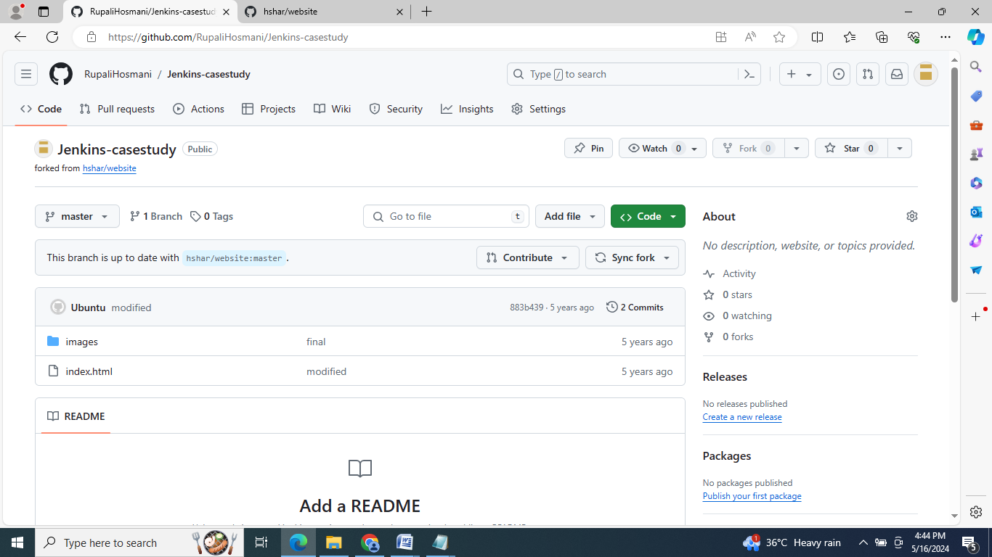

8. Clone the github repository on master machine

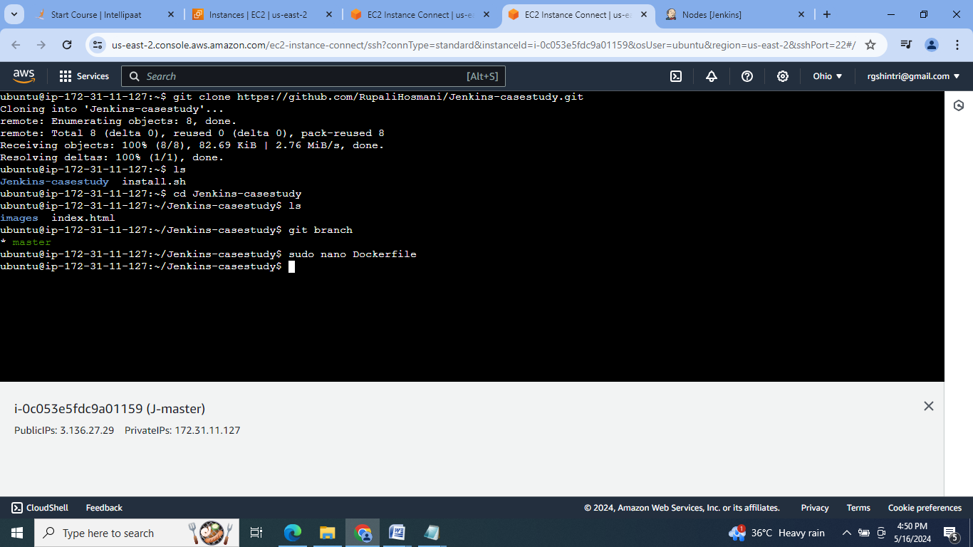

9. Create a Docker file to create image of “images” & index.html files, add & commit the same:

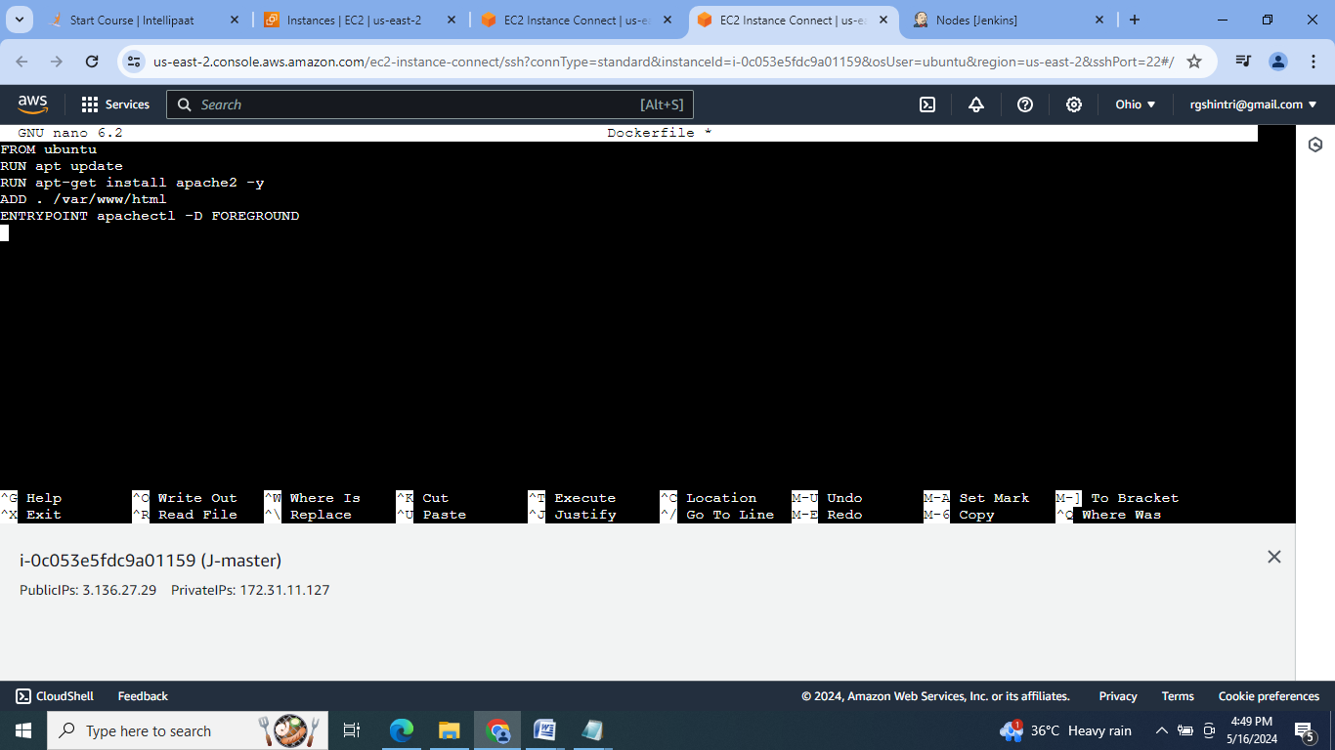

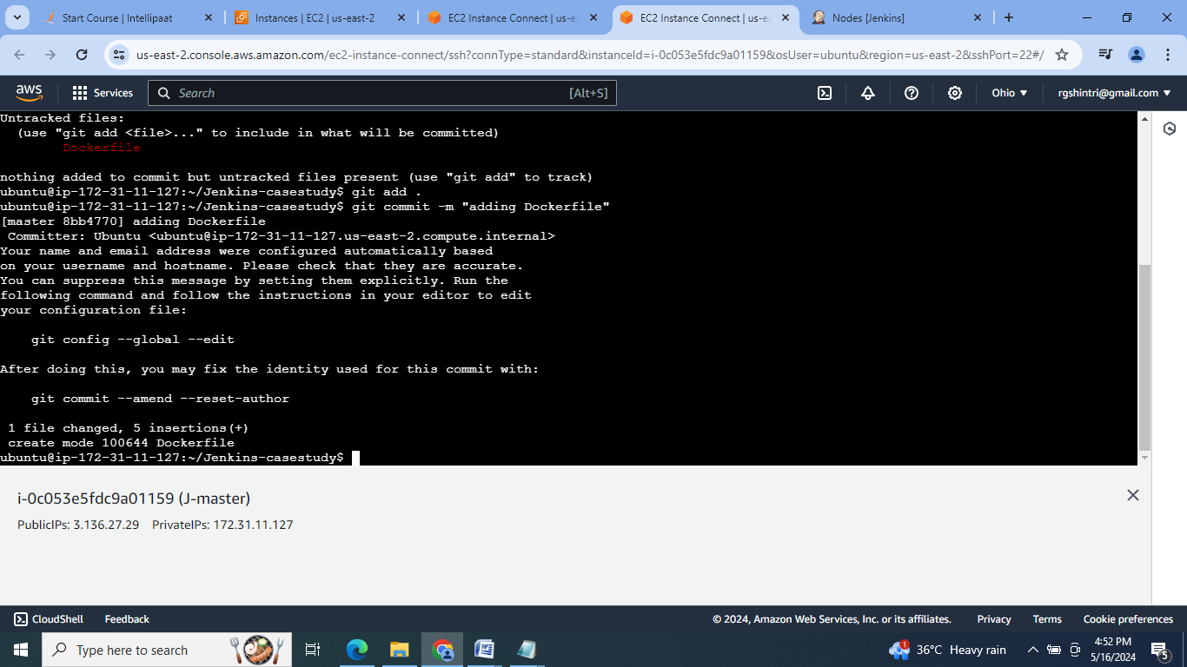

10. Create the new develop branch:

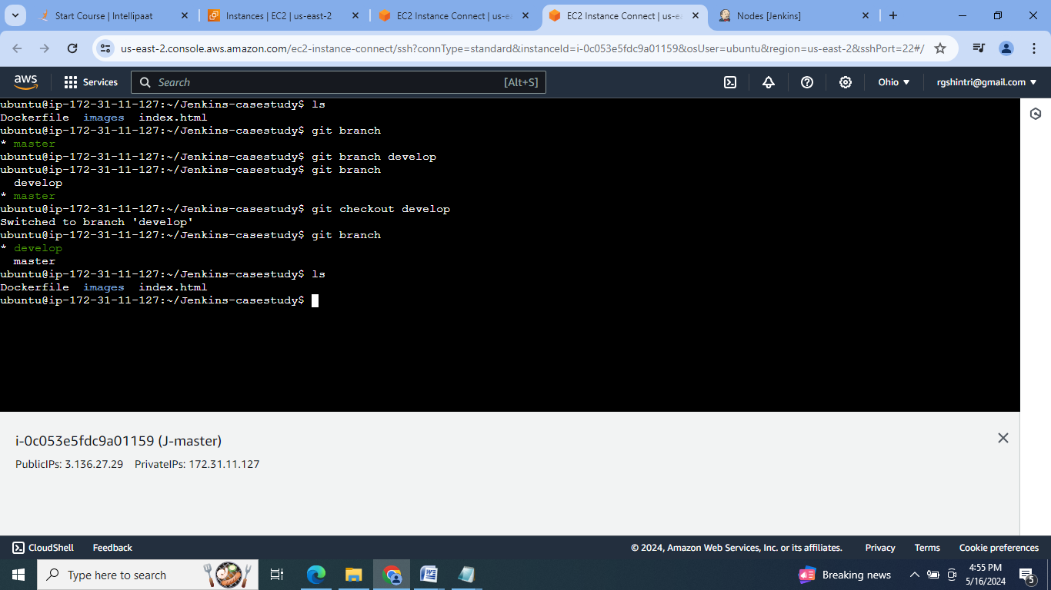

11. Now create job1 in Jenkins by adding webhook for if commit is made to develop branch, just build the product:

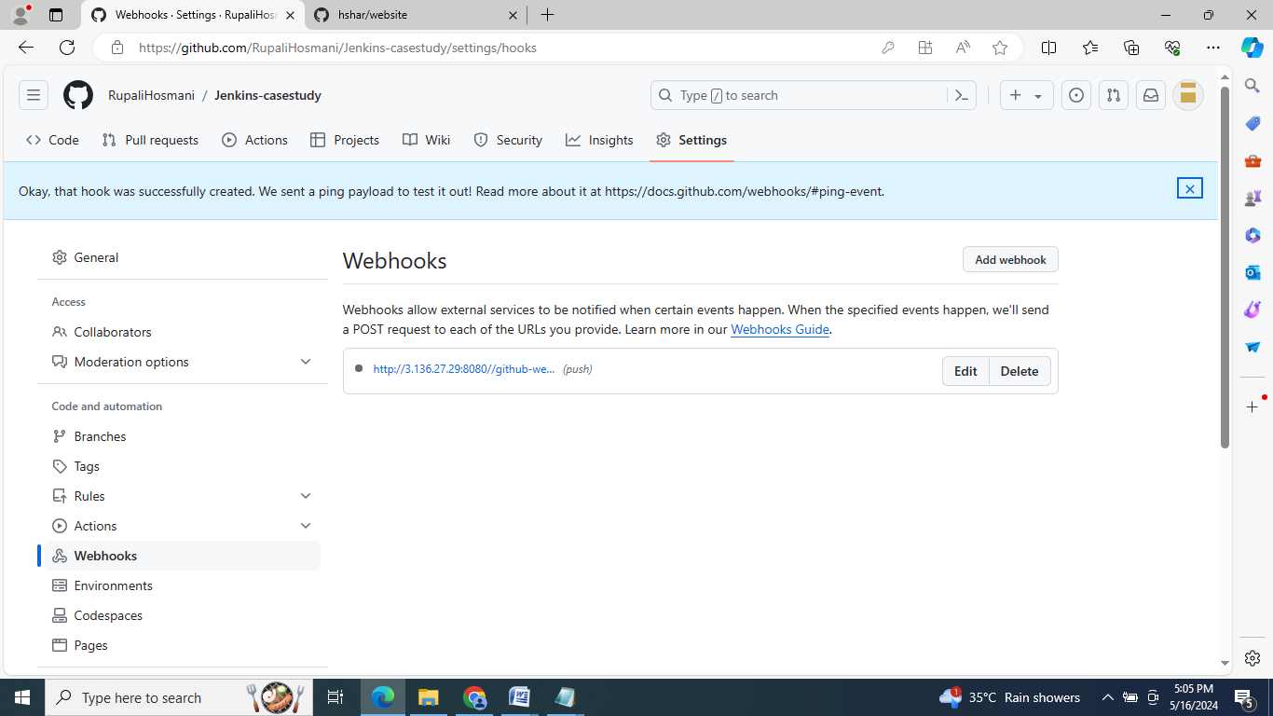

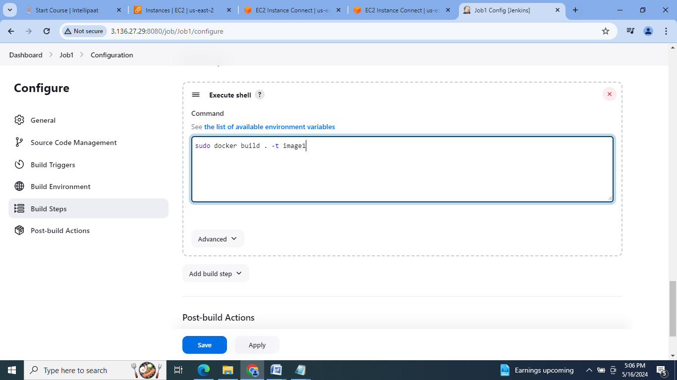

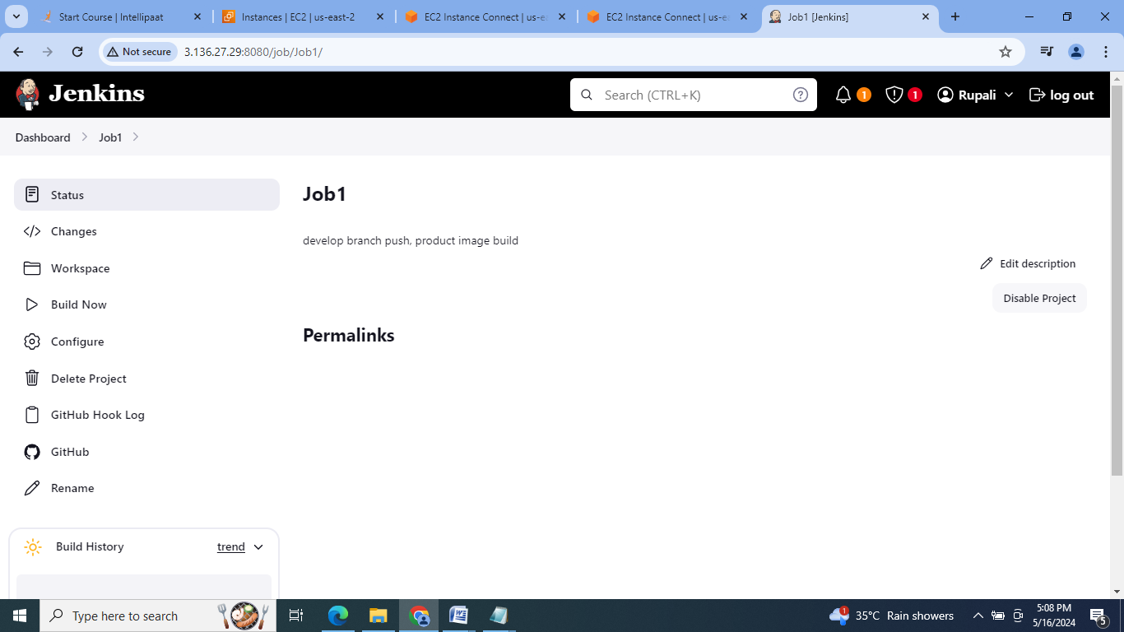

12. Push the develop branch, generate the token for password & check the job1 status:

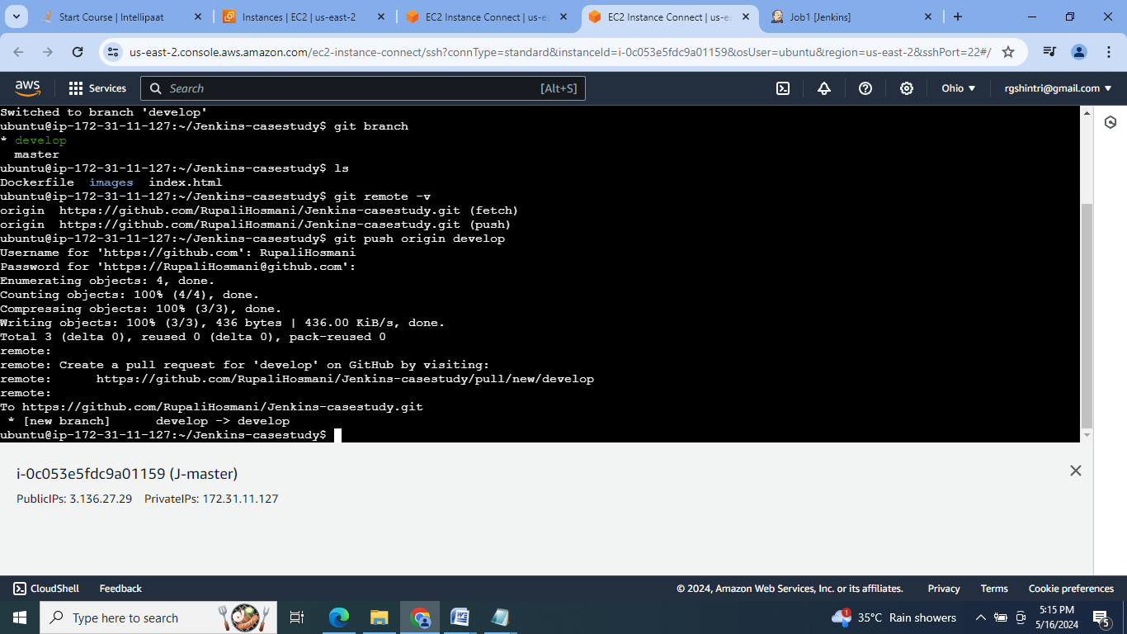

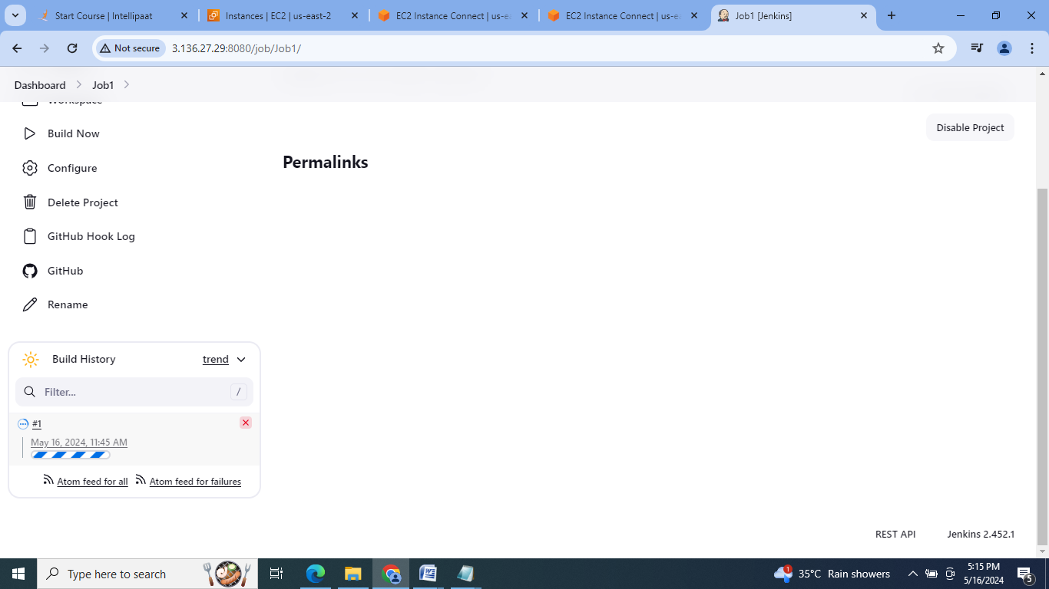

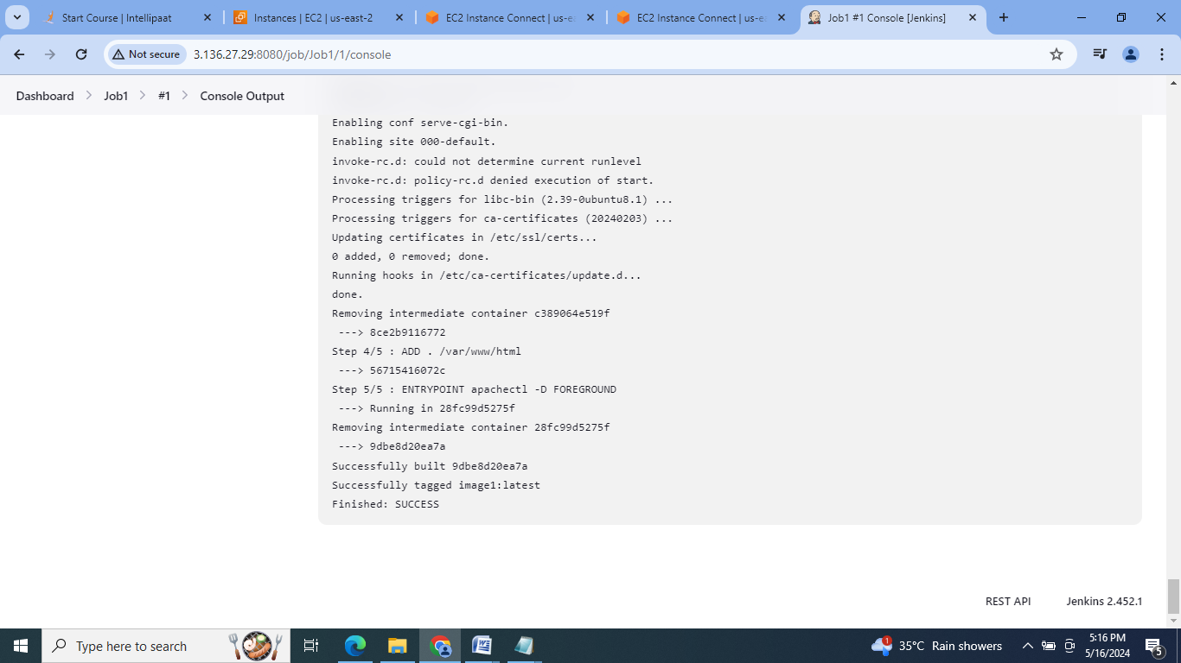

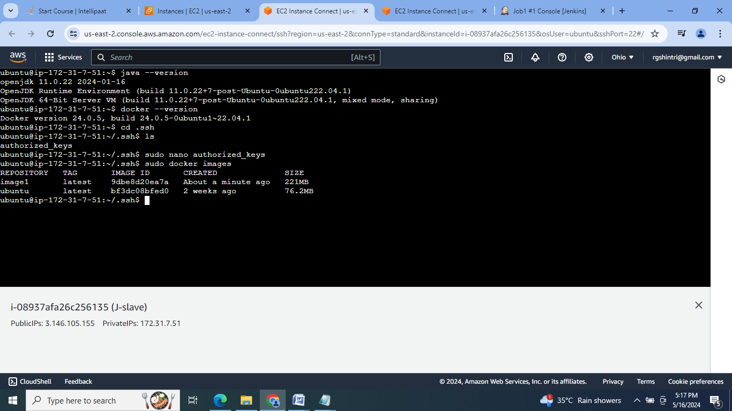

13. Create job 2 for pushing master branch , building product & publish the website at port 82:

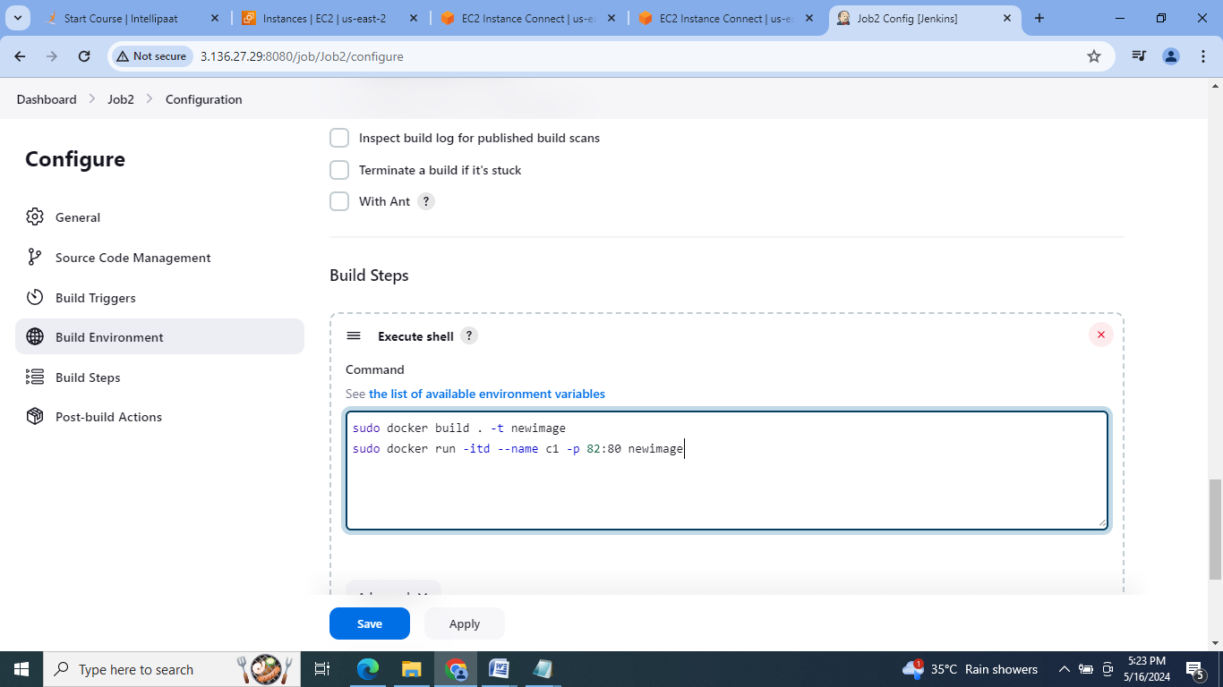

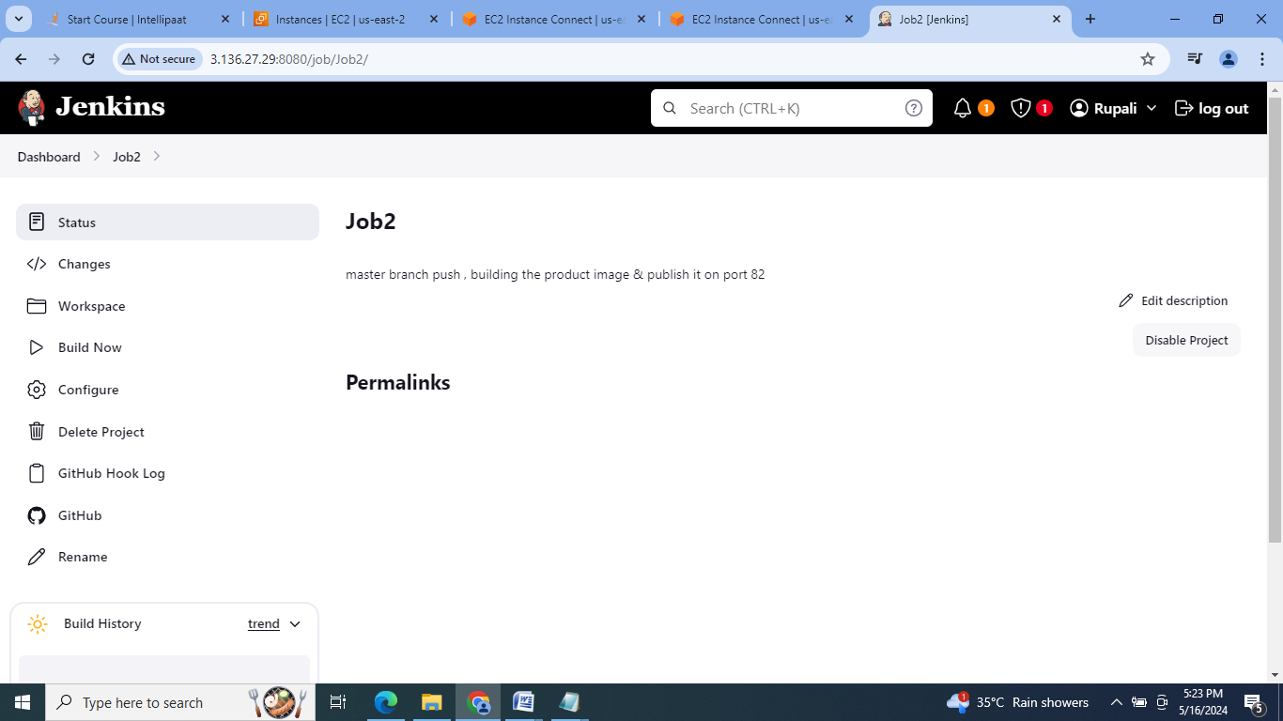

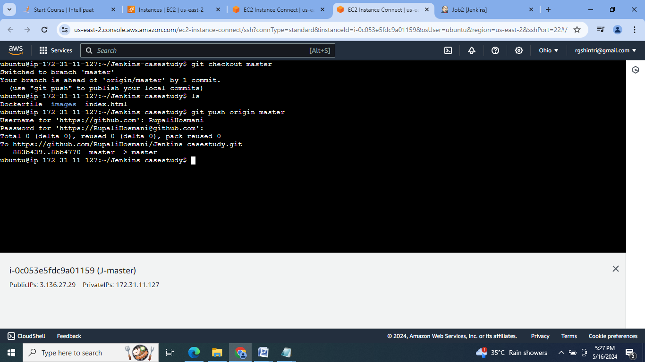

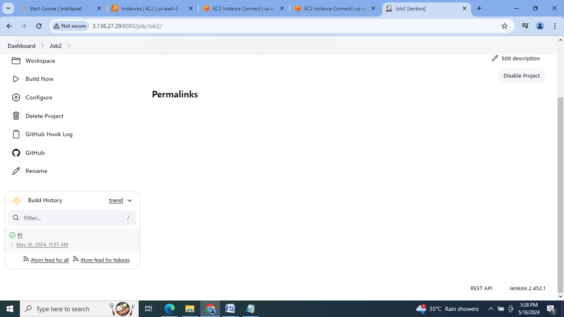

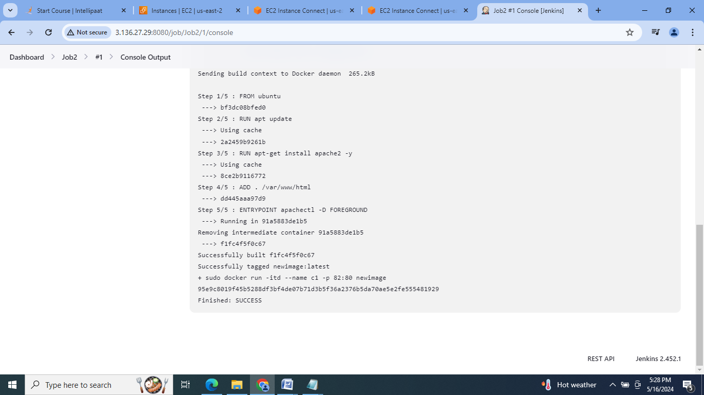

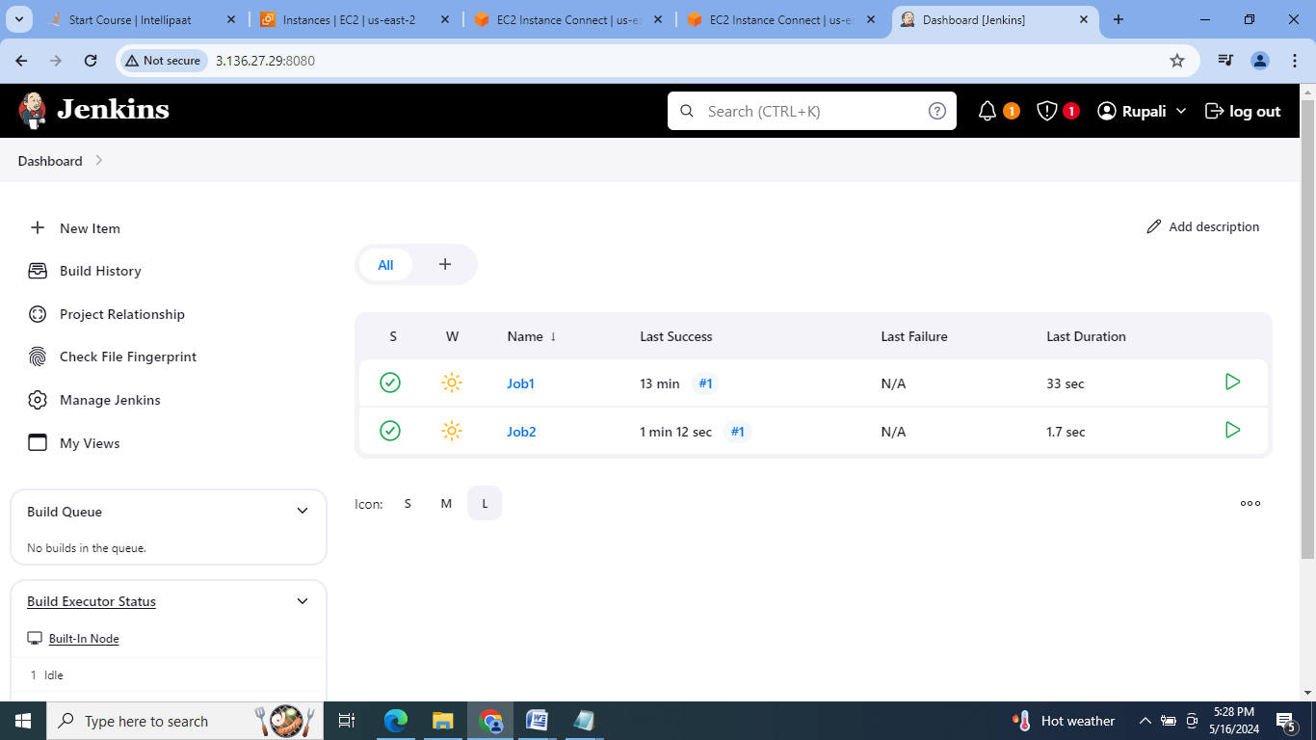

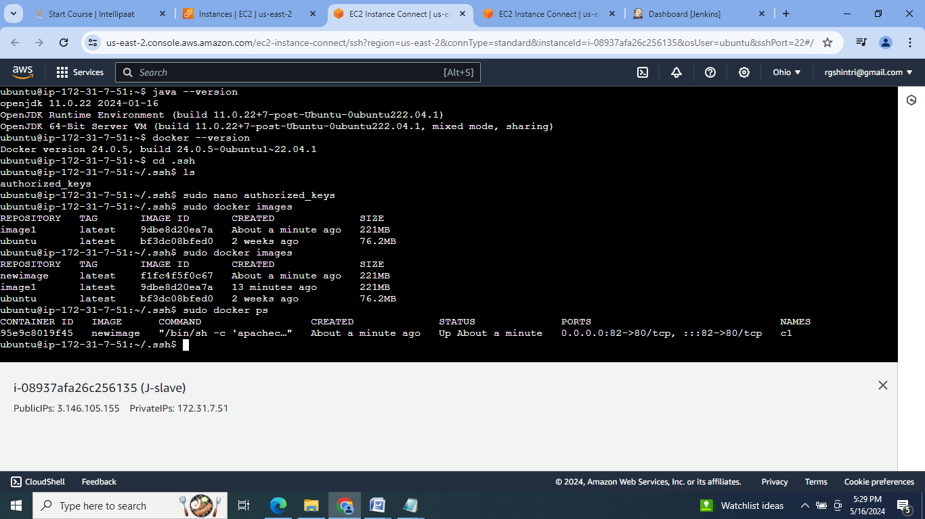

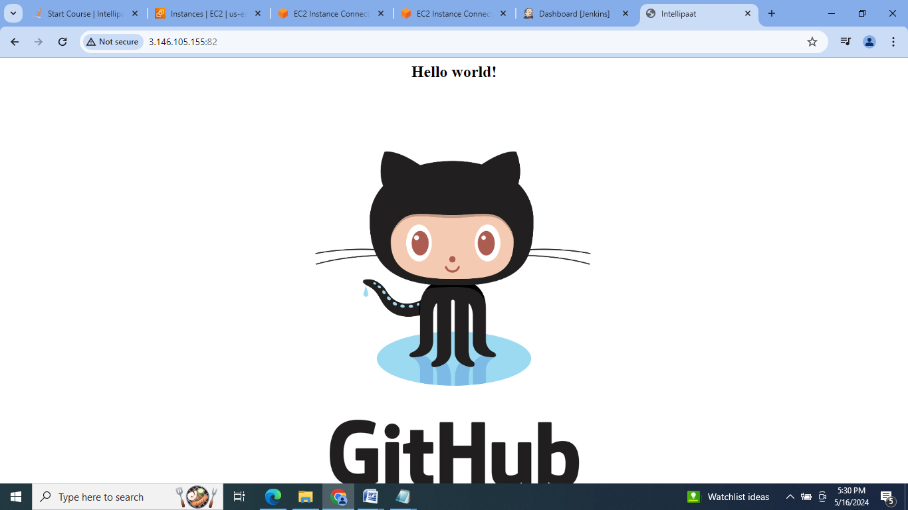

**Conclusion:** Jenkins is an open source automation tool which helps to automate software development process by doing the continuous integration & providing the base for continuous delivery.

